Project Management Report

Team Members :   
Kendall Bingham

Vidya Sridhar

# Report

*A short report on project management including screenshots of your project management/agile websites on project planning and task management and also your agile website link.*

Tool Used : Agile-Fant

Description:

For planning this project, we used the tool AgileFant. It was particularly useful for task management. It gave us the opportunities of creating tasks and subtasks and modeling every project objective into :   
  
Stories

Substories

The responsibilities and task points were also given to each task for prioritization.

For every increment, we set up tasks for each member and gave the final status (‘started’/’not started’/’pending’ and done’) once our task was done.

The final breakdown in the form of a chart could be seen.

AgileFant Url :

http://cloud.agilefant.org/community/

https://cloud.agilefant.org/community/dailyWork.action

Screenshots :

First Increment :

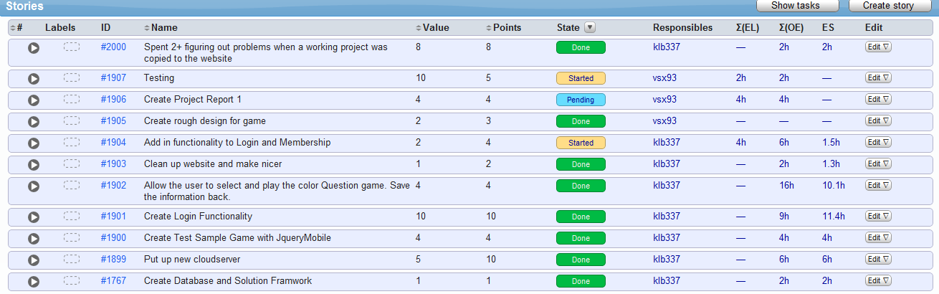

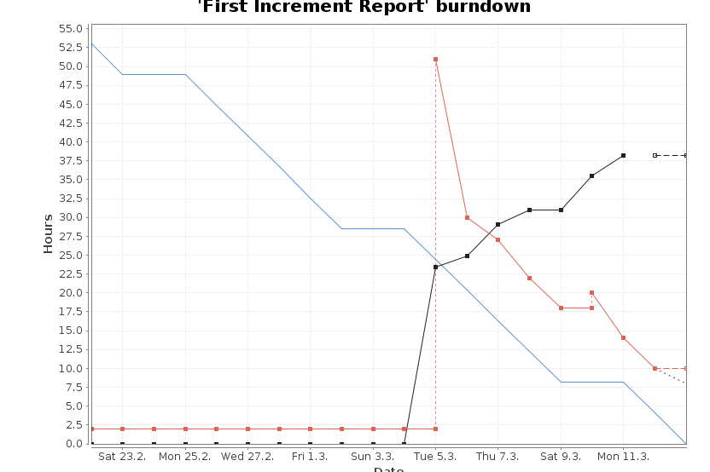

Second Increment

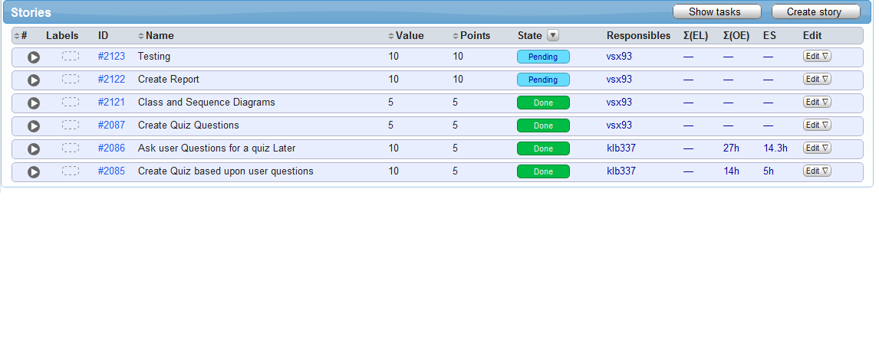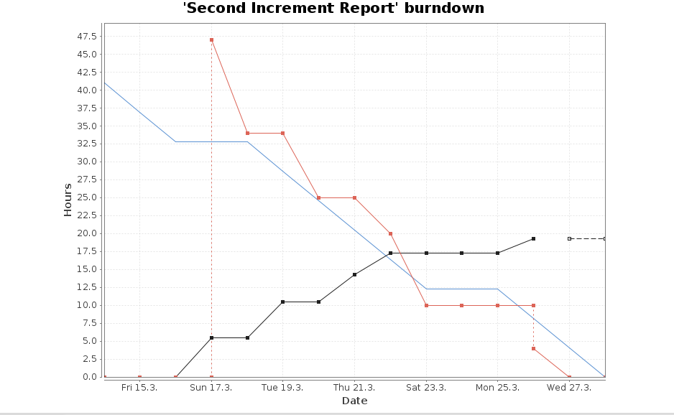

Third increment:

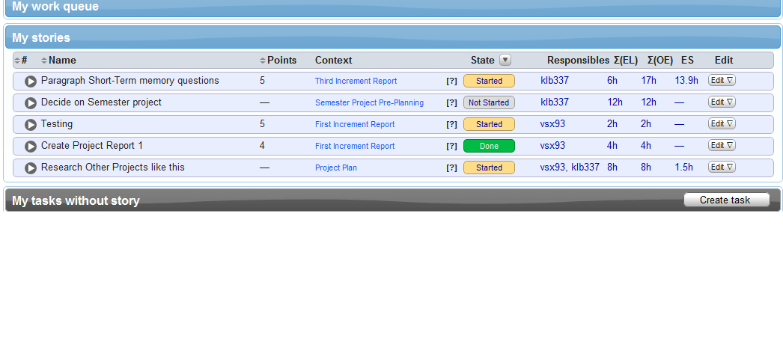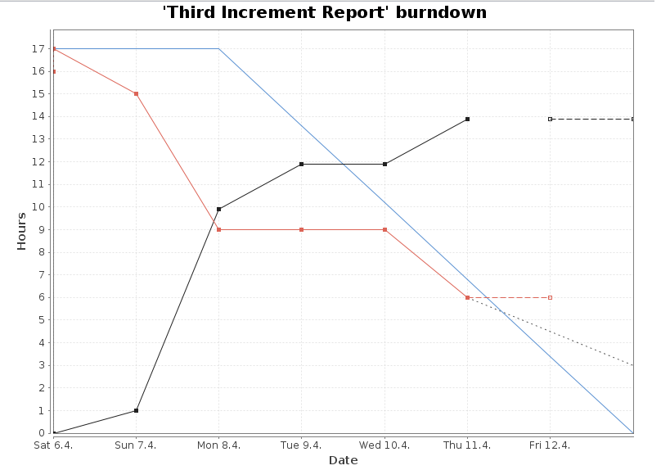

Fourth Increment:

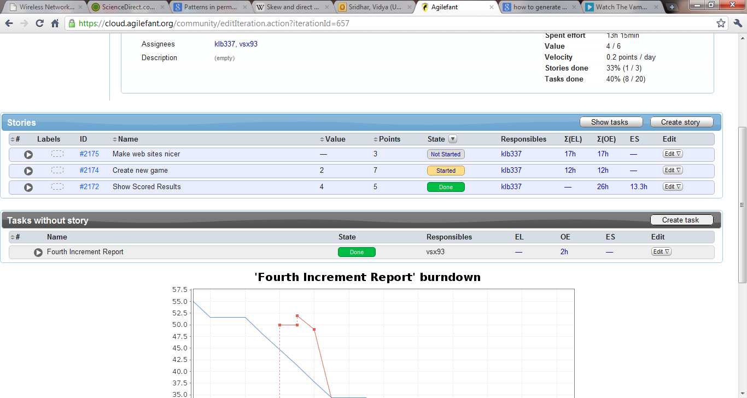

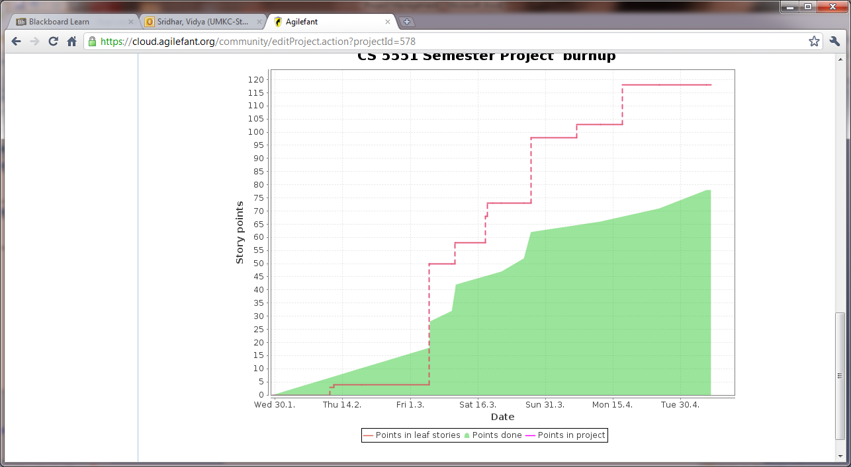

# Final project evaluation*:*

*The purpose of this document is to evaluate your final project. The document provides an opportunity to step back and put things in perspective and appreciate how much you have accomplished: discuss how well your project satisfies your original requirement specifications, were you satisfied with your design process? How helpful was the agile process? How would you do the agile process next time? Did you stick to your project plan schedule? What was the real management structure within your group? Does it bear any resemblance to structure that you had planned? Any recommendations for next year?*

* The document and agilefant helped us realize our project potential and original specifications in a well organized manner, and we are very satisfied with our design process.
* The agile process was very helpful because developing each task became more efficient and organized once we broke them down into stories and sub storied.
* Using the agile process next time, we can also try add more tasks and perhaps use other project websites in addition to agilefant.
* We stuck to our project plan schedule
* The structure was very similar to the organization of tasks shown and recorded on agilefant.
* It was a pleasure working with this tool.
* In the future, perhaps we can use team viewer in addition to agilefant because it is more dynamic in nature.